**Project Title : MEASURE OF ENERGY CONSUMPTION**

**In t*he context of measuring energy consumption in AI systems, there are several solutions and approaches to consider:***

* **Power Measurement Tools:** Utilize hardware-based power measurement tools like power meters or specialized chips (e.g., Intel RAPL) to measure the actual power consumption of the AI hardware during operation. These tools can provide real-time power consumption data.
* **Software Profiling:** Use software-based profiling tools that monitor the CPU, GPU, and other hardware components to estimate energy consumption based on their utilization. Tools like NVIDIA's NVProf and Intel's VTune can help with this.
* The Nvprof Profiling tools enables to collection and view Profiling data from the command-line. Output -profile can output a data file for later import into either nvprof or the NVIDIA visual profile

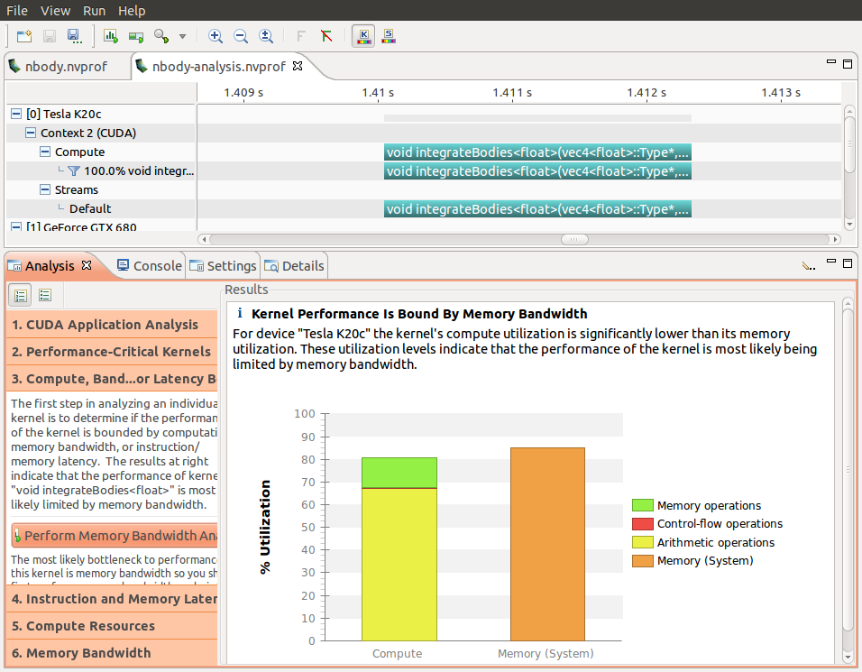

* **Energy Profiling Libraries:** Some Libraries and frameworks , like tensor flow and putorch , offer built -in Profiling capabilities that can estimate energy consumption based on the hardware usage during AI model training or inference

Examples scripts for pytorch, tensorflow, numpy and describe an integration with Docker integration. In a nutshell,

* The code to measure energy between a start and stop signal.

from deep_ learning_power _measure .power_ measure import experiment, parsers

driver = parsers. Jsonparcer("output _folderexperiment.Experiment(driver)

p, q = exp.meqsure_yourself(period=2) # measure every 2 seconds

###################

# place here the code that you want to profile

################

q. Put(experiment.STOP_MESSAGE)

* This will create a directory output_folder in which a power_metrics.json will contain the power measurements.

**Summary of the recordings**

From deep_learning_power_measure.power_measure import experiment, parsers

Driver = parsers.JsonParser(“output_folder”)

Exp_result = experiment.ExpResults(driver)

exp_result .print()

* Model output for This code,

***================= EXPERIMENT SUMMARY ===============***

***MODEL SUMMARY: 28 parameters and 444528 mac operations during the forward pass***

***ENERGY CONSUMPTION:***

***on the cpu***

***RAM consumption not available. Your usage was 4.6GiB with an overhead of 4.5GiB***

***Total CPU consumption: 107.200 joules, your experiment consumption: 106.938 joules***

***total intel power: 146.303 joules***

***total pspys power: -4.156 joules***

***on the gpu***

***Vidia total consumption: 543.126 joules, your consumption: 543.126,***

* **Energy Modeling :** Create energy models for different AI hardware components and workloads. These models estimate energy consumption based on various factors, such as CPU/GPU usage, memory access patterns, and algorithm complexity.
* AI Modeling-based Optimization of an Industrial -Scale steam during for moving towards net -in the energy sector

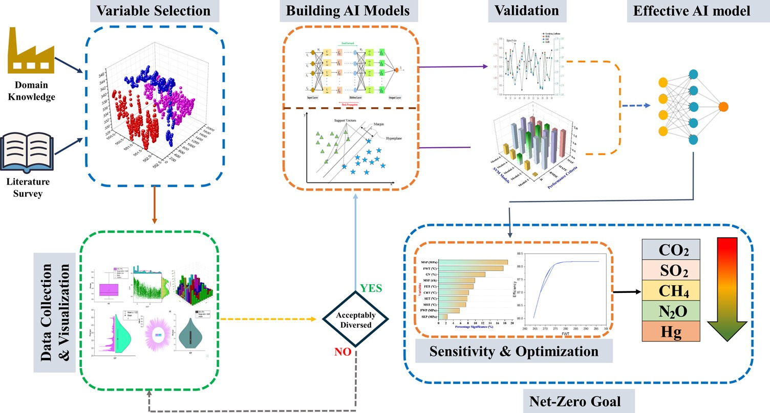

* **Energy Efficient Hardware:** Choose energy-efficient hardware components, such as low-power GPUs or TPUs, for AI tasks. These components are designed to provide high performance while minimizing energy consumption.
* **Cloud-Based Monitoring:** If you’re using cloud-based AI service, Some providers of a monitoring and reporting tools that show energy consumption for the workloads .This can help to optimize the AI deployments.
* Cloud computing technique is helpful to monitor the data as well as storing data in cloud server two way communication protocal .
* 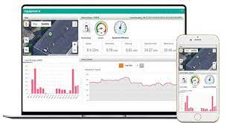Hence the propose system provides the entered electrical information in real time as a live energy report without any delay time.
* **Customized Power Management:** Implement Custom power management policies for the AI infrastructure. Dynamically adjust the power states of hardware components based on workload requirements to save energy
* **Benchmarking and Optimization:** Regularly benchmark your AI models and algorithms to identify areas where energy consumption can be reduced. Optimize your code and model architecture for energy efficiency.
* **Green AI:** Consider the principles of "Green AI," which focus on developing AI models and algorithms that are more energy-efficient by design. This includes techniques like model quantization, pruning, and knowledge distillation.
* **Monitoring and Alerts:** Set up monitoring systems that trigger alerts when energy consumption exceeds predefined thresholds. This allows you to react quickly to anomalies and optimize resource allocation.

By implementing these solutions and practices, that is effectively measure and manage energy consumption in AI systems, which is crucial for sustainability and cost-efficiency in AI deployments.